
Family 30 Metrics of Viability
Financial Viability—Total Expenses Target is Less than Ordinary Income

Church Utilization—How Full is the Church?
Average Sunday Mass Attendance divided by (Total Sunday Masses times Church Capacity)
The Archdiocese of Seattle has established Metrics of Viability for parish families as we move through the Partners in the Gospel process. These measure our parish strengths: our finances, our facilities, and how we use these resources. Consider these in the coming months as we prayerfully offer our thoughts on challenges and opportunities we face on the road to becoming one parish.

Evangelization 2023-2024 (no set target)
Total People per Category
 | Holy Spirit | St John
First Communion | 86 | 53
Confirmation | 201 | 6
Professions of Faith | 4 | 20
FF PreSch-5th | 161 | 115
FF Grades 6-8 | 5 | 58
FF Grades 9-12 | 88 | 41
FF Young Adults | 30 | 0
OCIA | 25 | 16
OCIA (children) | 24 | 8
Full Communion | 7 | 4

Masses per Priest per Weekend
(includes Saturday Vigil & Sunday Masses)
As of July 2025

Target = 3
Family 30 = 4.58
Insured Value of Buildings
Holy Spirit | $17,070,000
St John the Baptist | $11,251,000
Family 30 | $28,321,000
2023-2024 Maintenance
Holy Spirit | $33,266
St John the Baptist | $28,124
Family 30 | $61,390
Maintenance Spent Ratio
(total maintenance expense/ insured value of buildings)
Target > 0.635%
Holy Spirit | 0.19%
St John the Baptist | 0.25%
Family 30 | 0.22%
Parish Revolving Fund (Savings) Balance June 30, 2024
Holy Spirit | $767,111
St John the Baptist | $533,983
Family 30 | $1,301,094
Ratio PRF Savings to Insured Value
(PRF savings/ insured value of buildings)
Target >6%
Holy Spirit | 4.49%
St John the Baptist | 4.75%
Family 30 | 4.59%

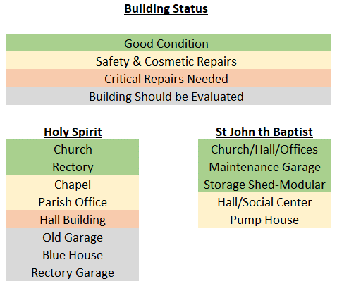
Family 30 Metrics of Viability

